**VCS Task**

**Task Description:**

Establish a new directory, populate it with script files, initiate an empty repository on GitHub, convert the local directory into a Git repository, and link it to GitHub for pushing the code into the repository. Perform merge, rebase, stash commands in following github repo.

===========================================================

1. **Establish a new directory: -**

Open **Visual Studio** 

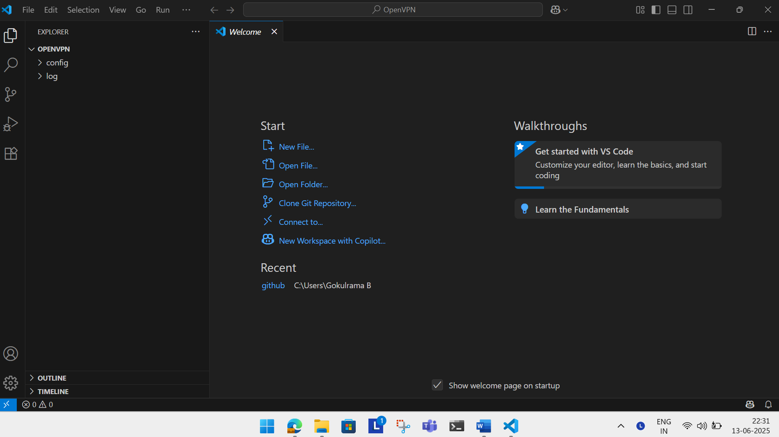

To **get the bash terminal** **at the bottom of the window** by clicking the **highlighted middle window icon on top right corner** in visual studio.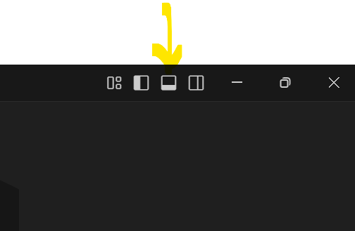

Once clicked the **highlighted icon**   you get the **terminal at the bottom** (Refer the below screenshot).

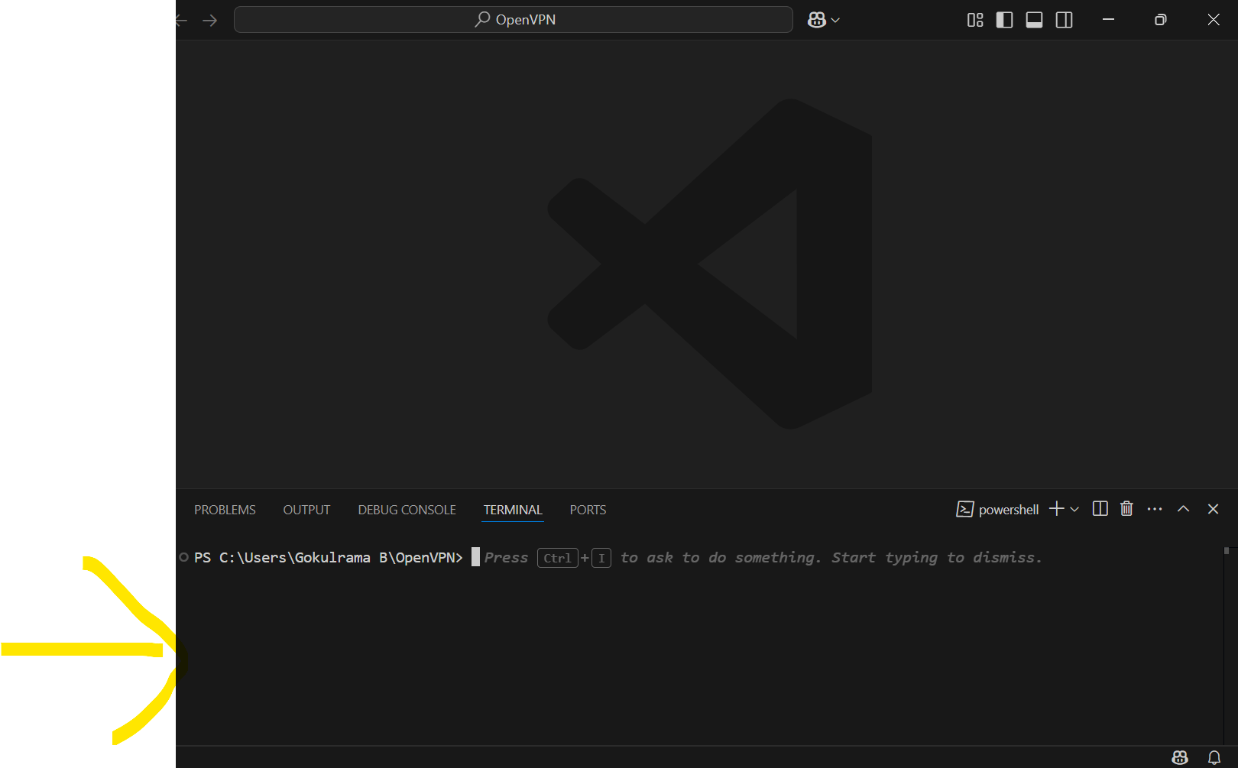

Select **dropdown menu ->** Choose **Git bash.**

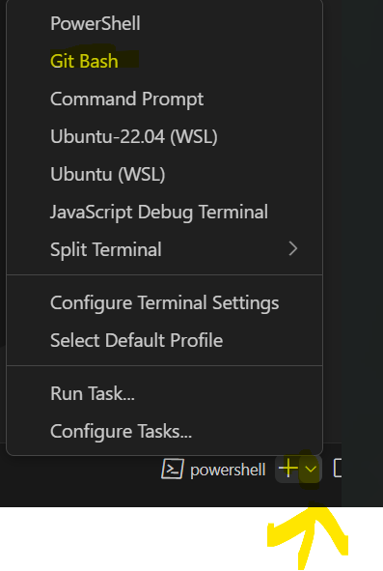

**The GIT bash terminal appears like below,**

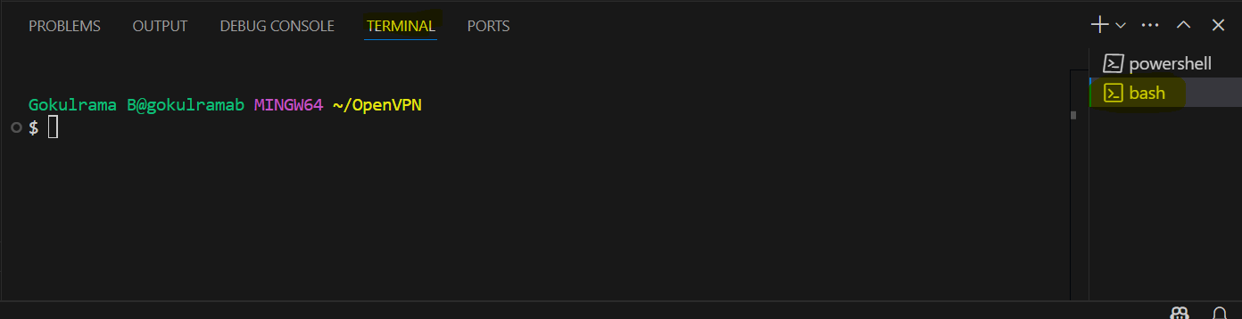

Select respective **GitHub** folder in **Visual studio** using **File -> Open Folder option**.

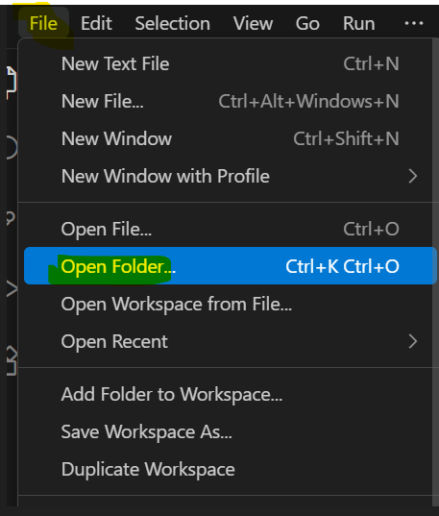

Choose respective **GitHub Folder [Highlighted below],**

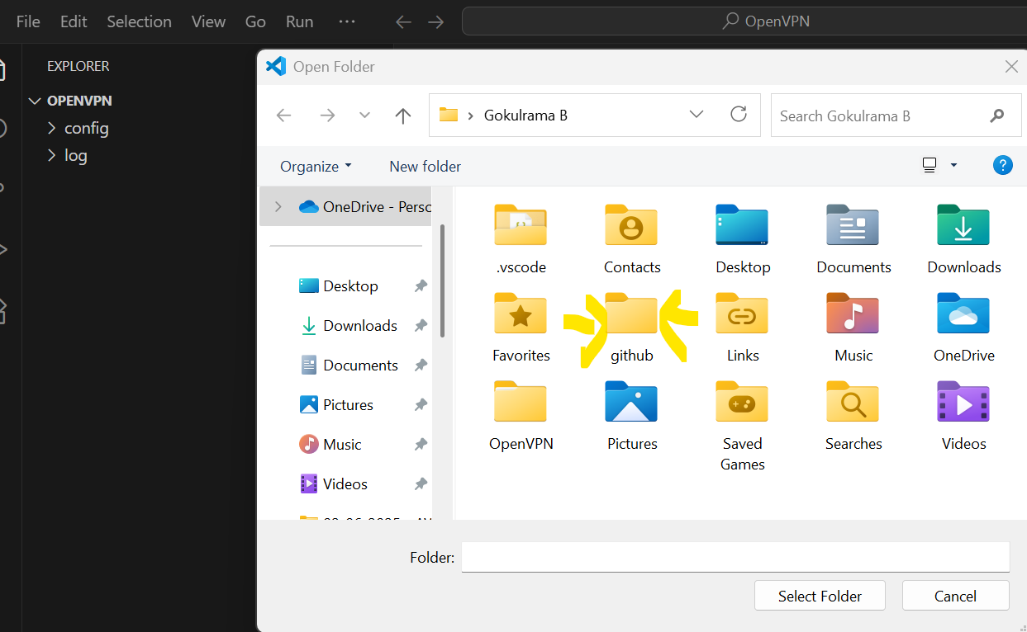

Then Click “**Select Folder**”

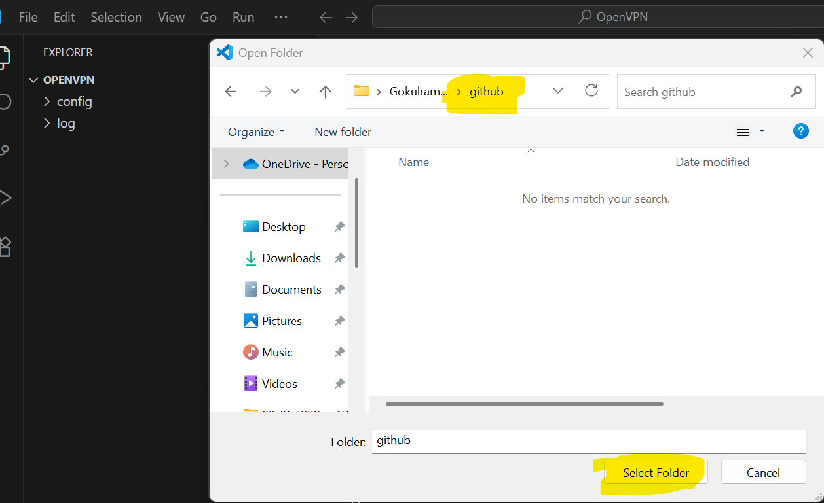

Once selected respective **Github Folder** then the **Git Terminal** looks like below,

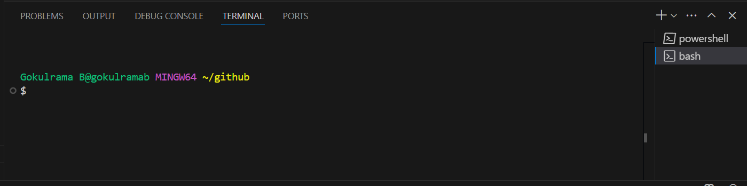

Establish a New Directory by using command **mkdir VCS_Task** [ **VCS_Task is a folder name**]

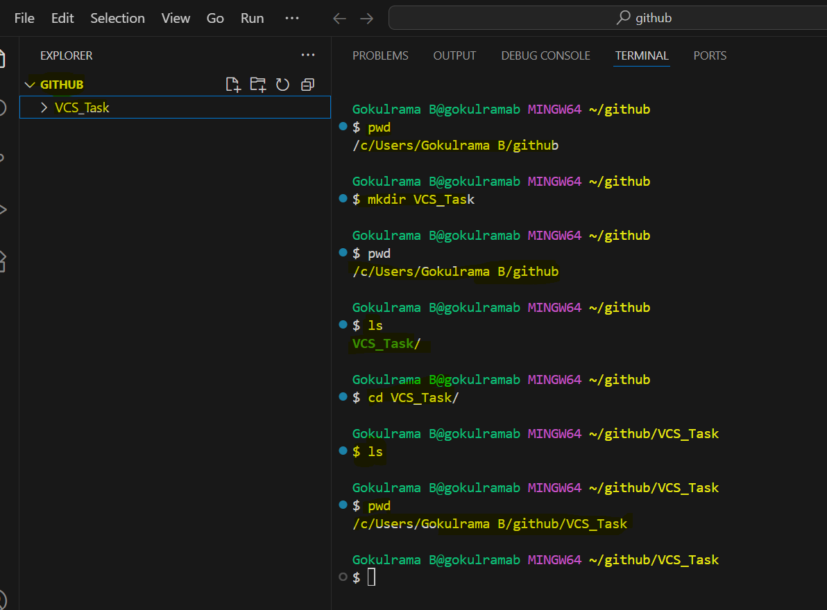

1. **Populate it with script files: -**

Using **touch command** to create empty script files.

**Command** is **touch filename.sh filename2.txt**

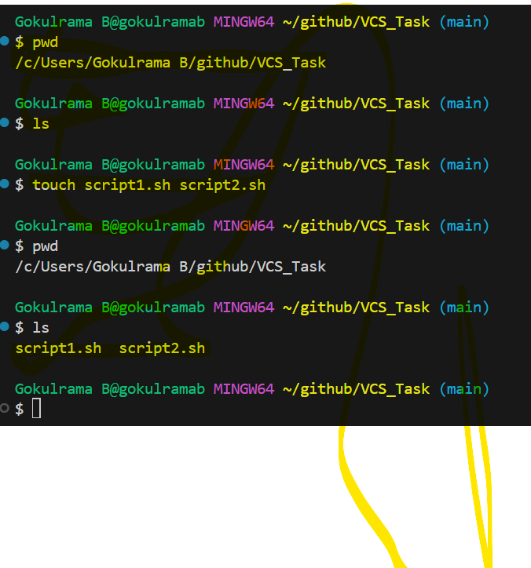

1. **Initiate an empty repository on GitHub: -**

**Create empty repository in GitHub**

Log into **GITHUB URL** [**https://github.com/login**](https://github.com/login)

**Once Logged into the above URL** using GIT Credentials **->** Click **New** to **create** **new repository in GITHUB.**

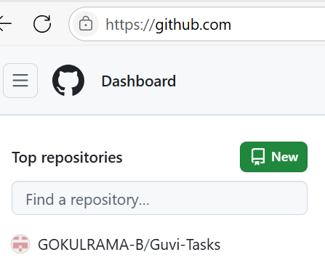

Once clicked **New** then you get **Create a new repository** window will appear (Refer the below screenshot)

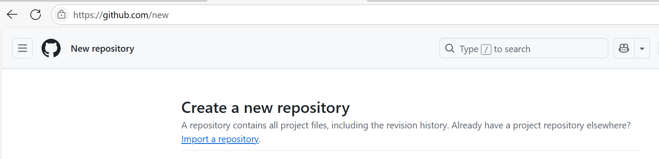

Give the **name** of **Repository** (**VCS_Task**) in Repository name

Select **Public** option and click **Create repository** (Refer the below screenshots)

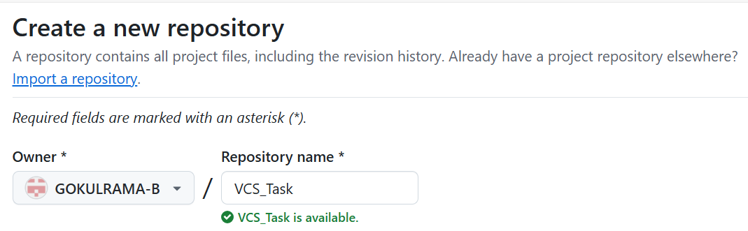





Once **created new repository** (**VCS_Task**) in **GITHUB** and it looks like below **[ Highlighted URL is GITHUB URL]**

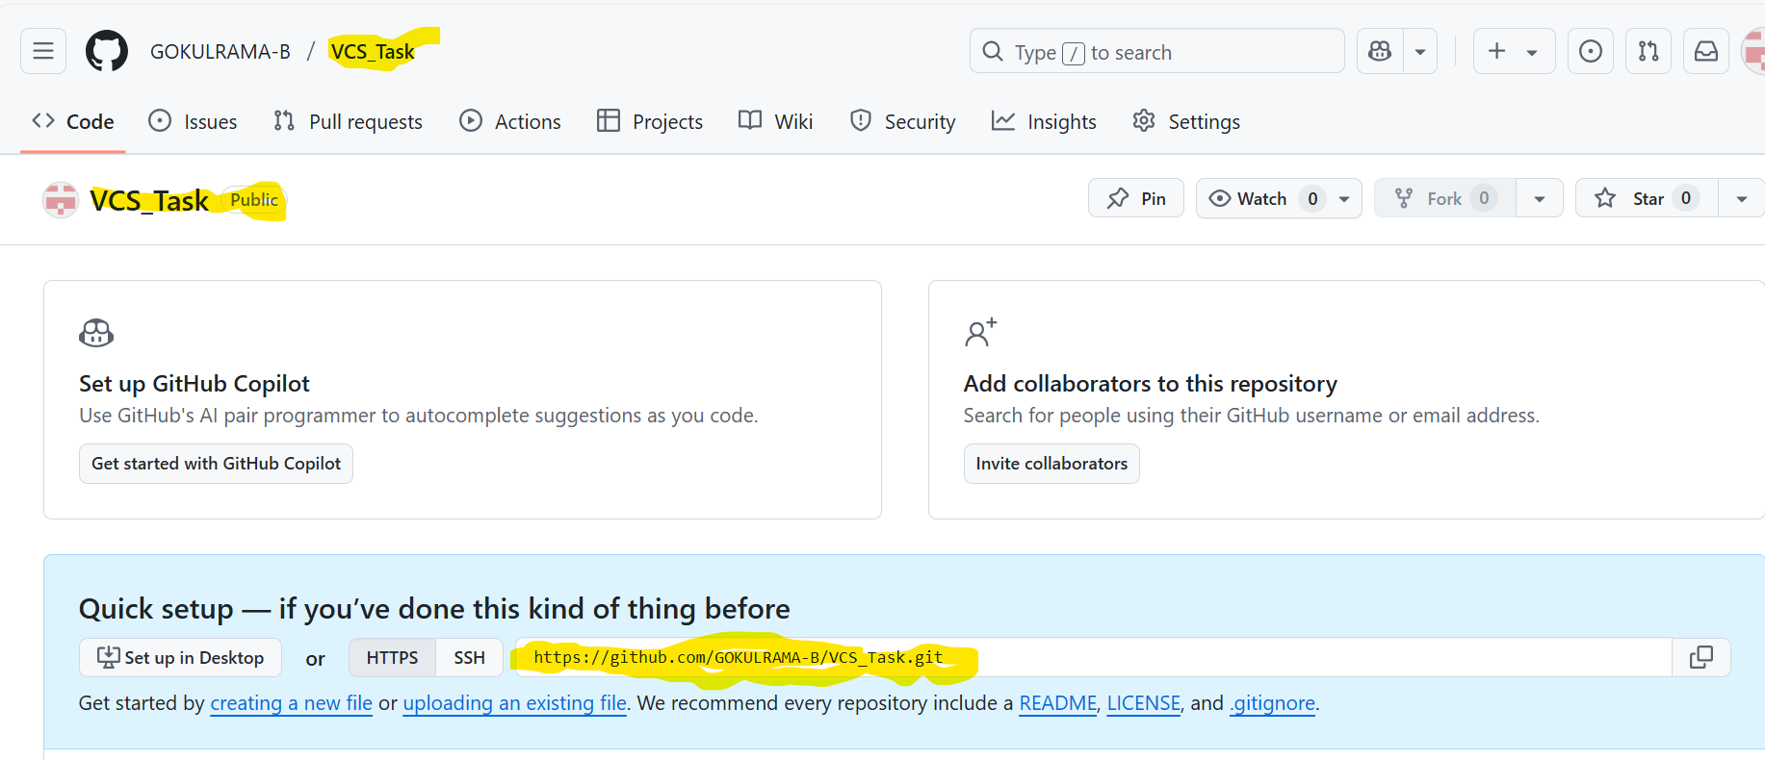

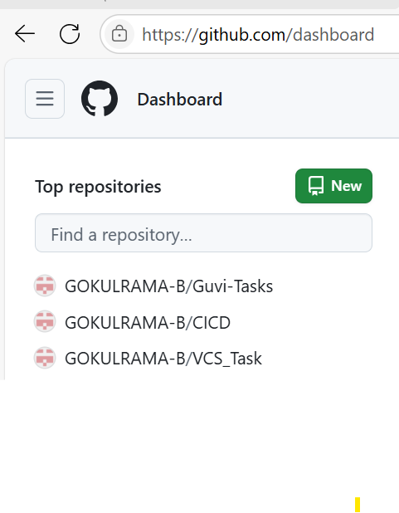

1. **Convert the local directory into a Git repository: -**

Create **a local directory** in **GIT repository**



1. **Link it to GitHub for pushing the code into the repository: -**

Create a **new empty repository** in **GITHUB**

**Repository Name** is **GIT_VCS_Task**

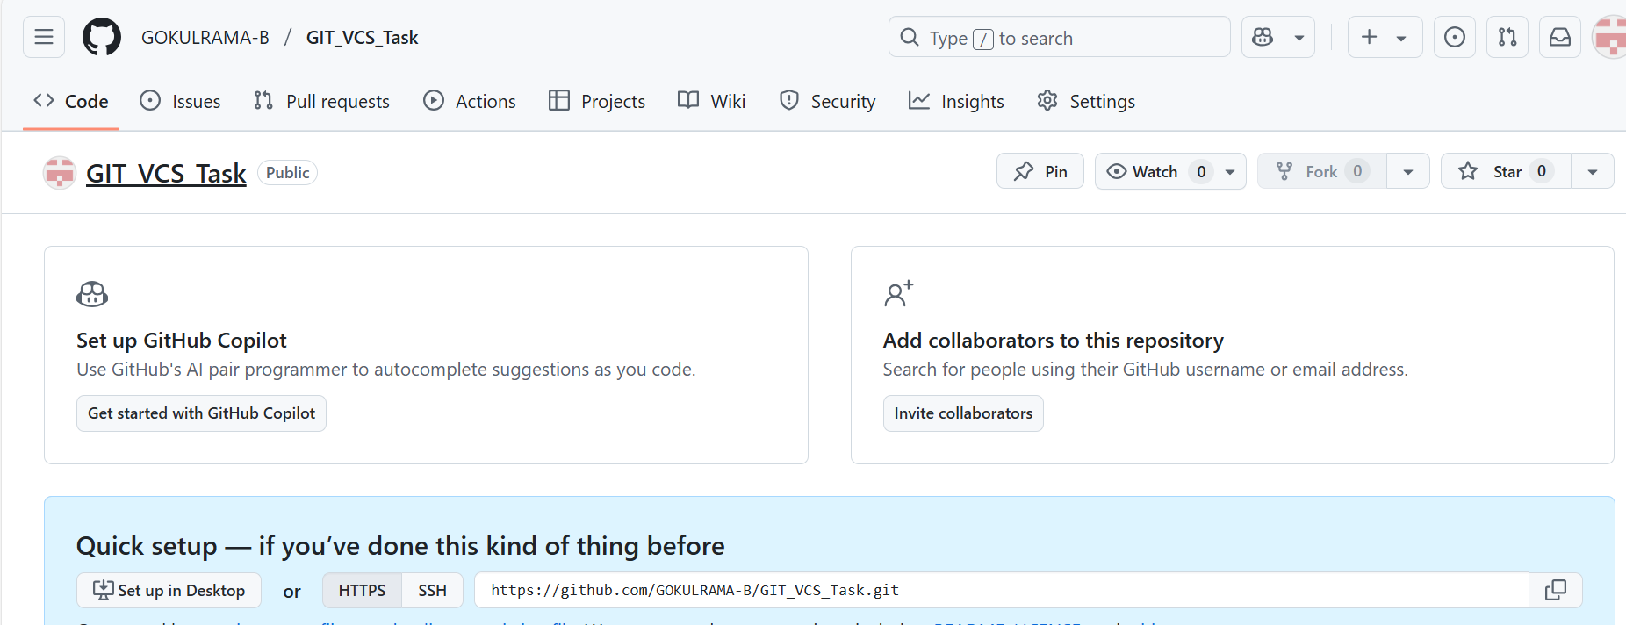

Go to **GIT Bash** terminal in **local machine** -> Create same repository

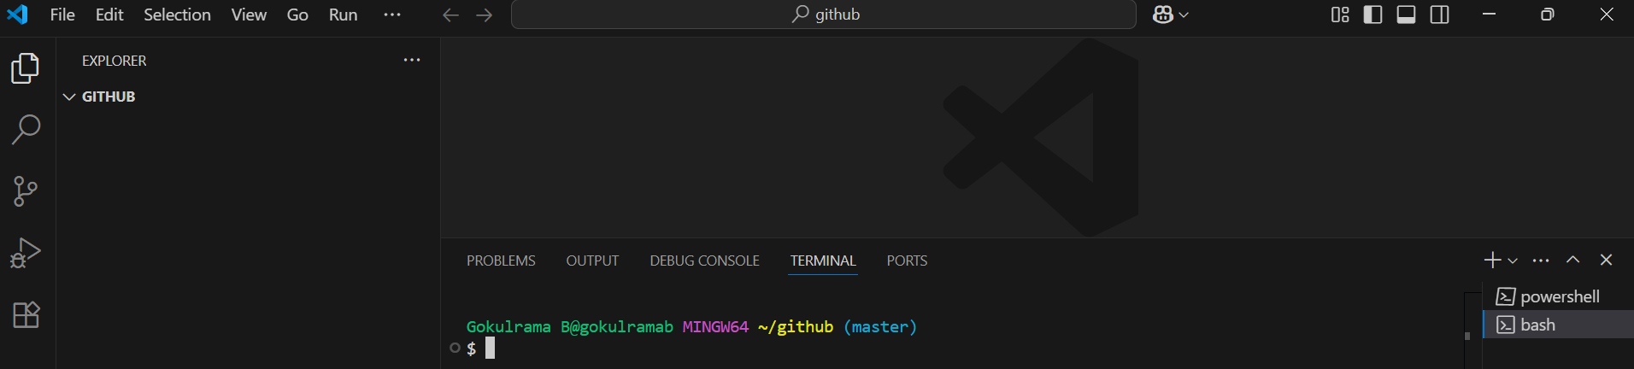

Create the **same repository** in **local GIT Bash Terminal [ Repository name GIT_VCS_Task]**

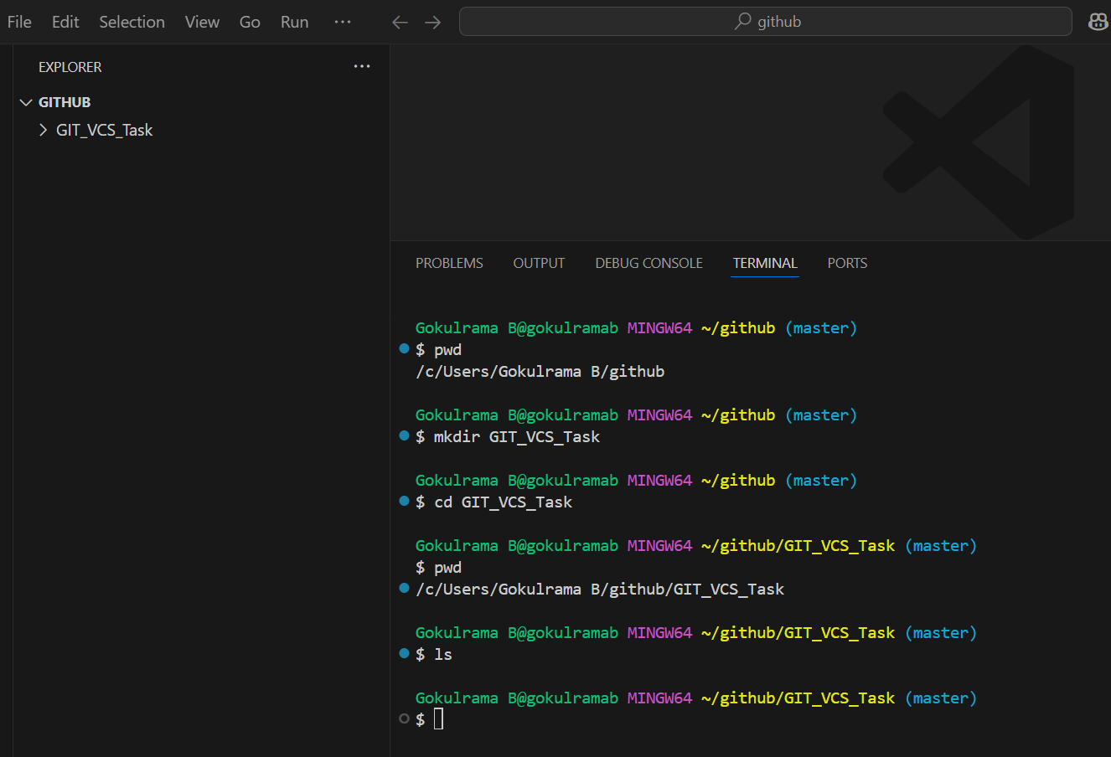

**Initialize** **Empty GIT repository**

**Command is git init**

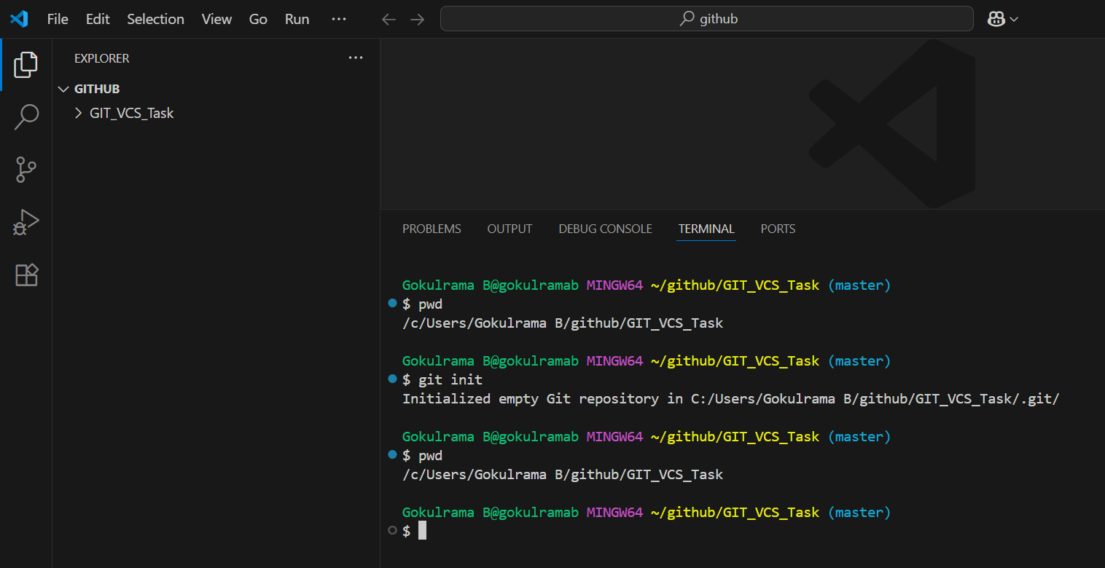

**Create a new file in local GIT repository using New File option.**

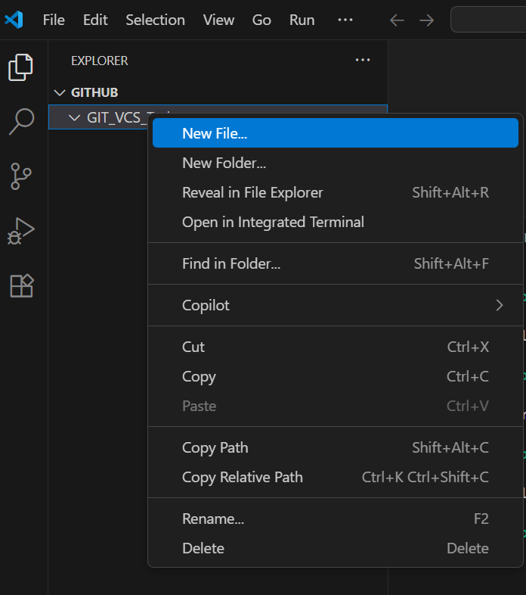

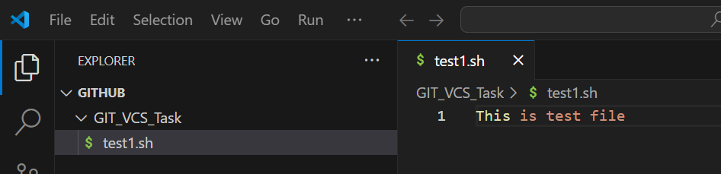

Push the file (test1.sh) from local GIT repository (GIT_VCS_Task) to remote GITHUB (GIT_VCS_Task) repository.

Moving the file to **staging stage** using the below command,

**Command is** **git add .**

Once you moved the file into **staging stage** just **committing the file** andsaved the fileinto **local repository.**

**Command is git commit -m “Enter a message”**

**git commit -m “First commit”**

Mapping the **local repository to remote repository** by using the below command,

Command is **git remote add origin <Enter the remote repository URL>**

**git branch -m main**

**git push -u origin main**

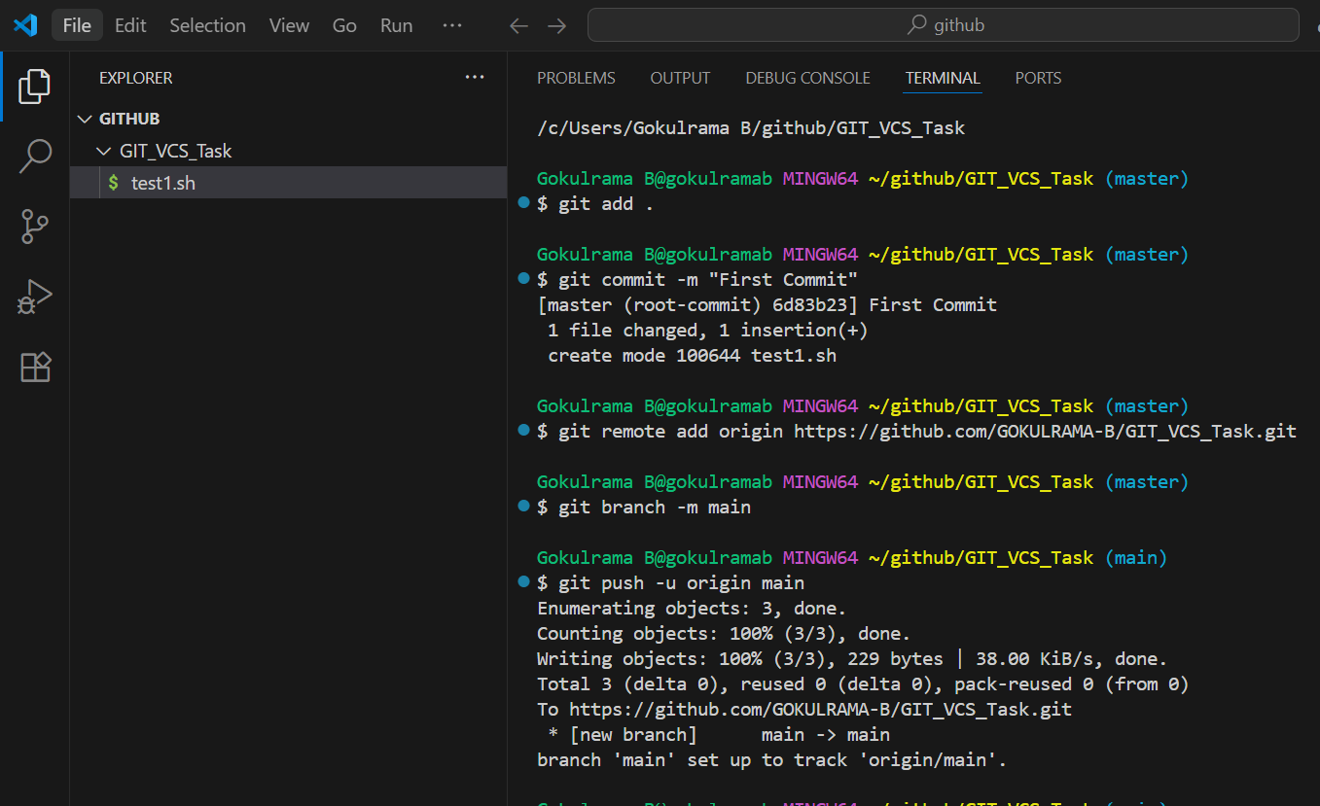

Now the file (**test1.sh**) moved into remote repository (**GITHUB**)

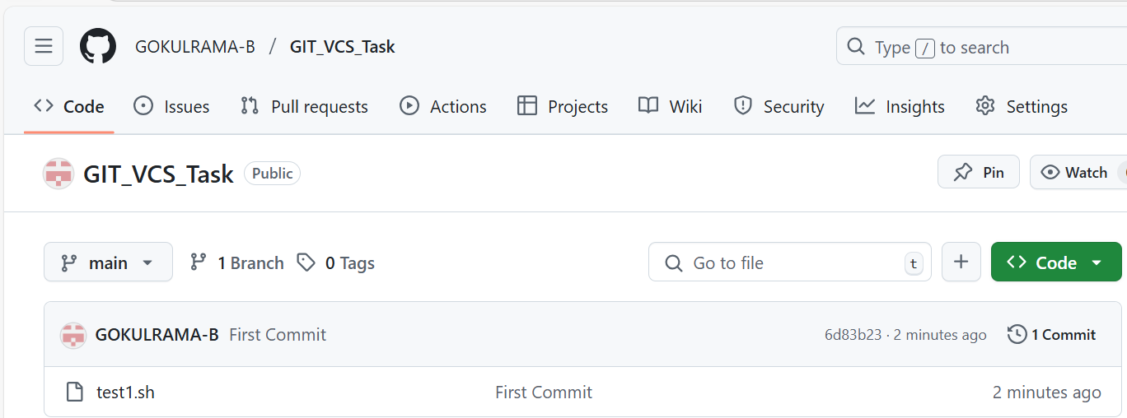

1. **Perform merge, rebase, stash commands in following GitHub**

**Repo: -**

**Merge command: -**

Created a new remote repository (Repository Name – **GUVI_Task**) in GITHUB

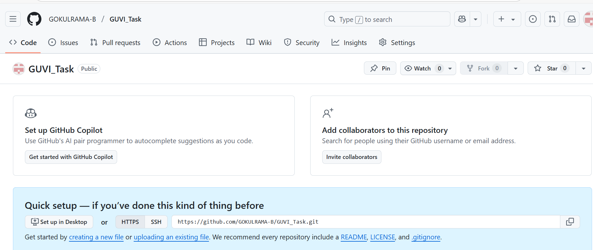

Add a **new file** [**File Name – test1.sh**] in the above created **GITHUB** repository 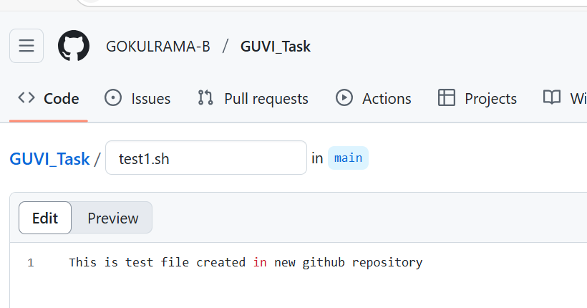

Enter **commit message** is Create test1.sh and **commit the changes**

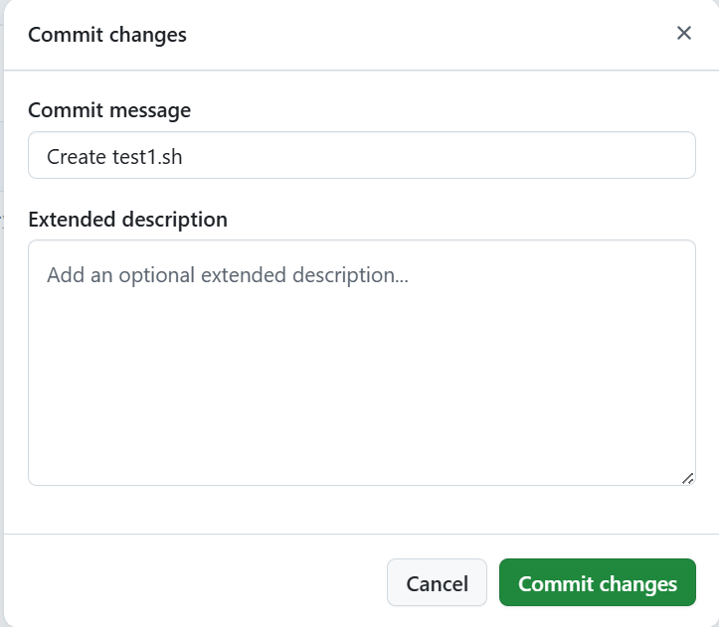

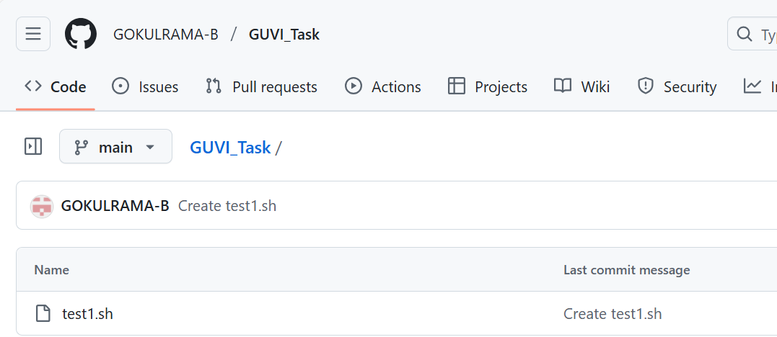

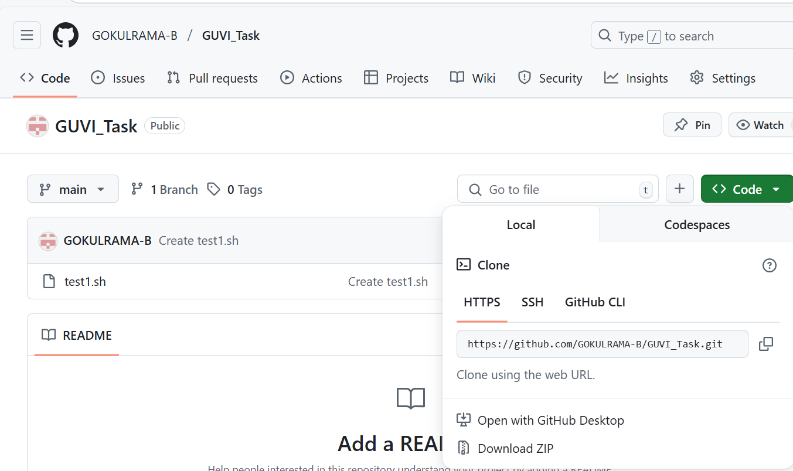

Goto **Visual studio -> File -> Open Folder** -> Choose **github** -> Click **Select Folder**

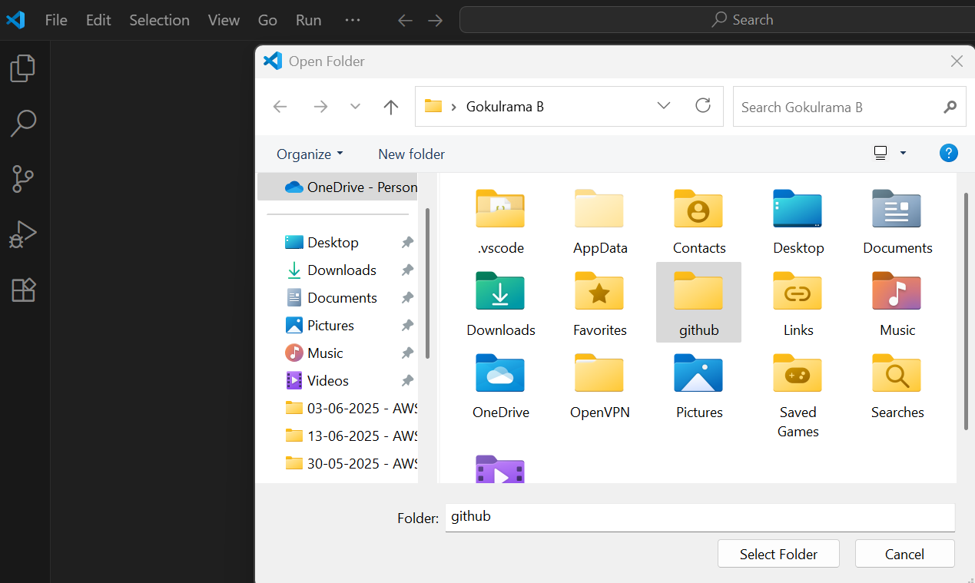

Below shown folder is **normal folder** **not GITHUB folder**

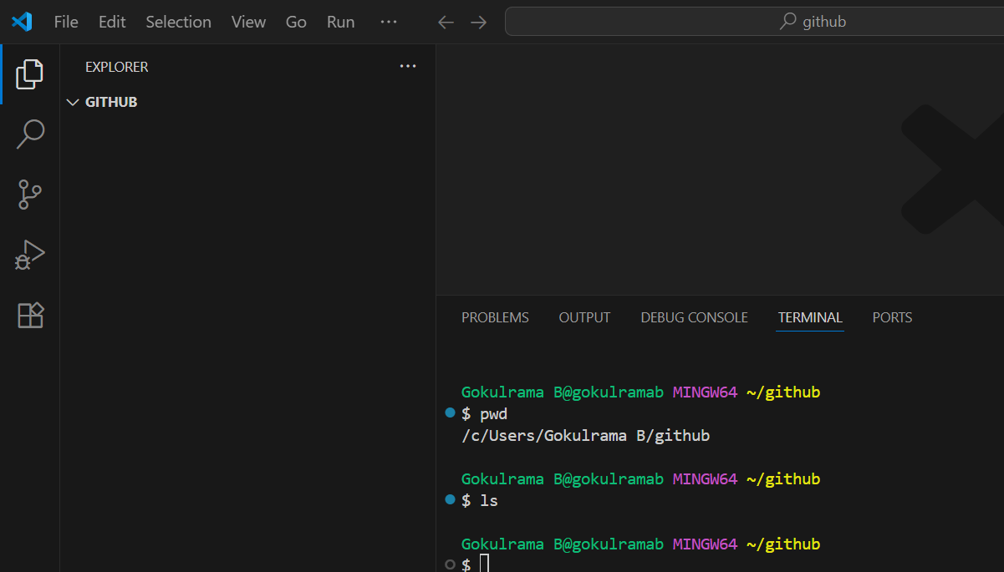

Now using **Clone option** to clone folder from **GITHUB** (Remote repository) to **GIT** (local repository)

**Command is git clone <remote repository url>**

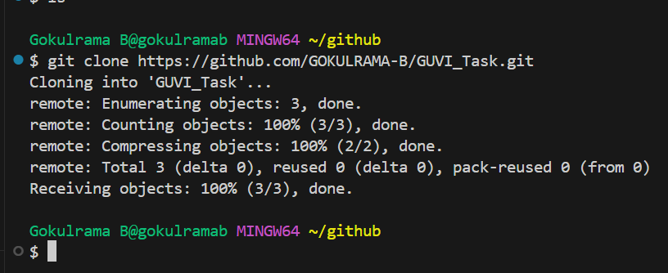

Once **cloned** into local GIT repository the cloned folder looks like below,

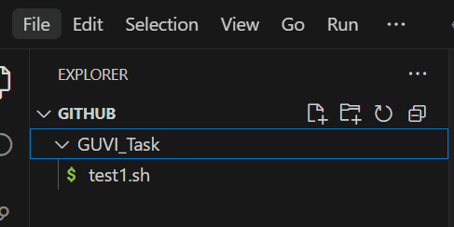

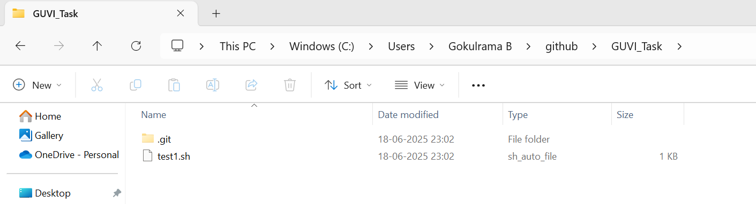

**Note – If the local folder is GIT folder (.git folder created and its a**

**hidden folder**

In the below screenshot, **already main branch default branch** is available.

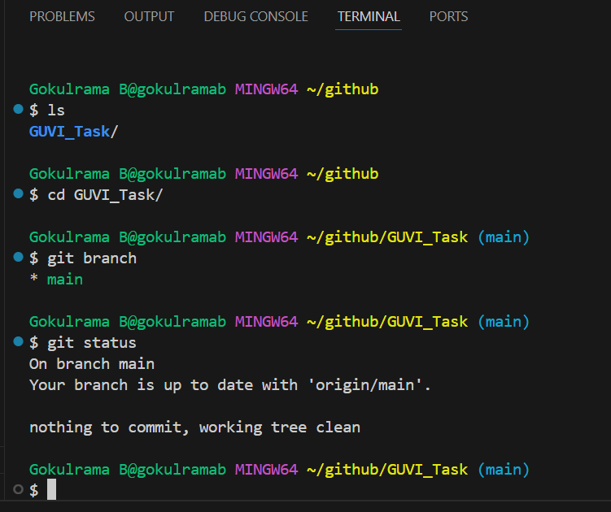

Now I am going to **create one new branch (dev)** in **working area.**

**Command is git branch <branch name>**

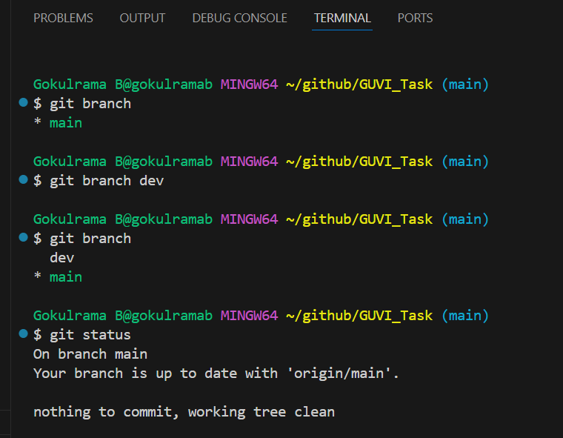

Once **created new branch (dev)** and going to **create a new file (test2.txt)** in working area.

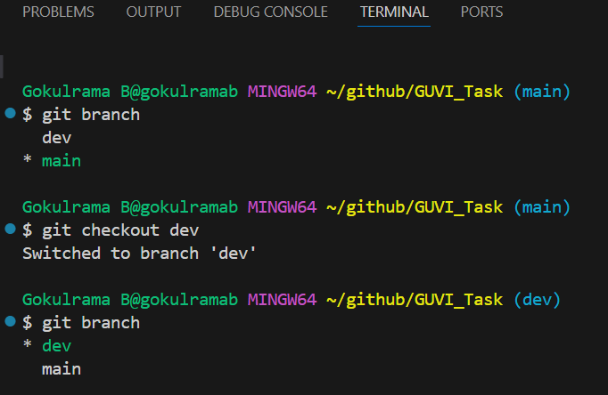

Once **file added in working area (dev branch)** and the **file status**

**marked as “U”**

**Here U means Untracked**

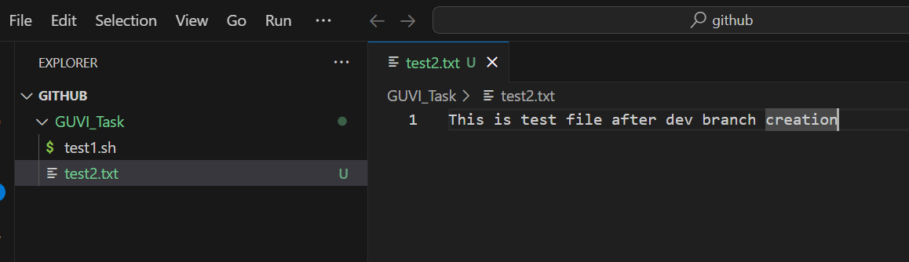

Now using **git add command** is used to **add the file from working area to staging area and the file status changed from “U” to “A”**

**Here A means “Added to staging area”**

**Command is git add <filename>**

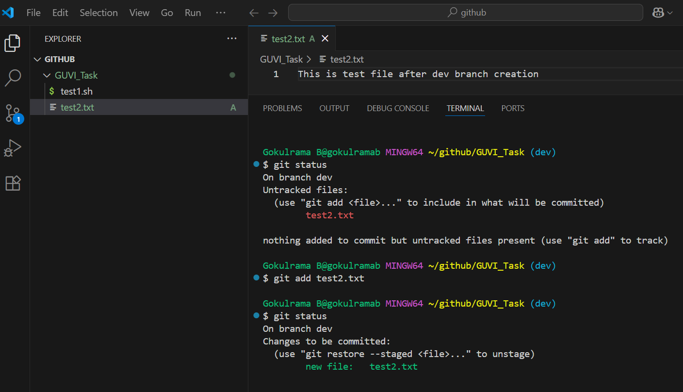

**Post the file added to staging area then** **do commit operation to move the file from staging part to local git folder.**

**Command is git commit -m “Enter message”**

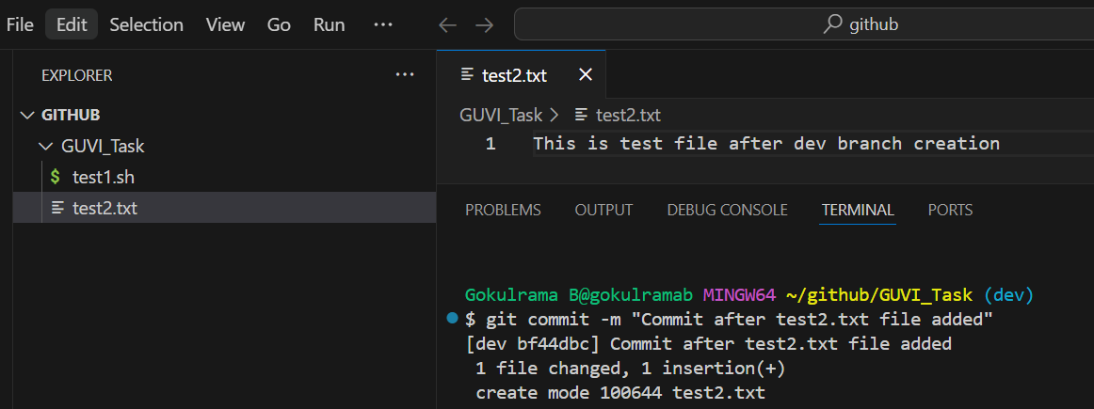

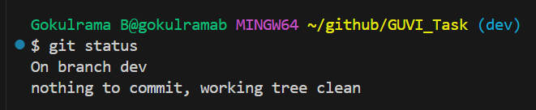

Once the **file available in local git folder** then **push the file to remote GITHUB repository**.

**Command is git push origin <branch name>**

**Here created the file in dev branch and push the file into same branch in GITHUB**

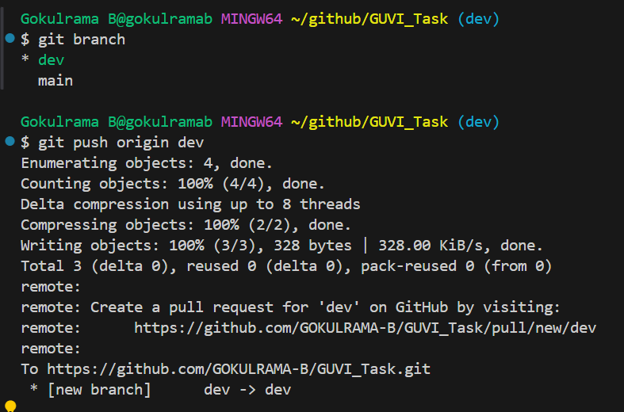

Now the **test2.sh file is available in GITHUB (dev) branch and not**

**available in GITHUB (main) branch.**

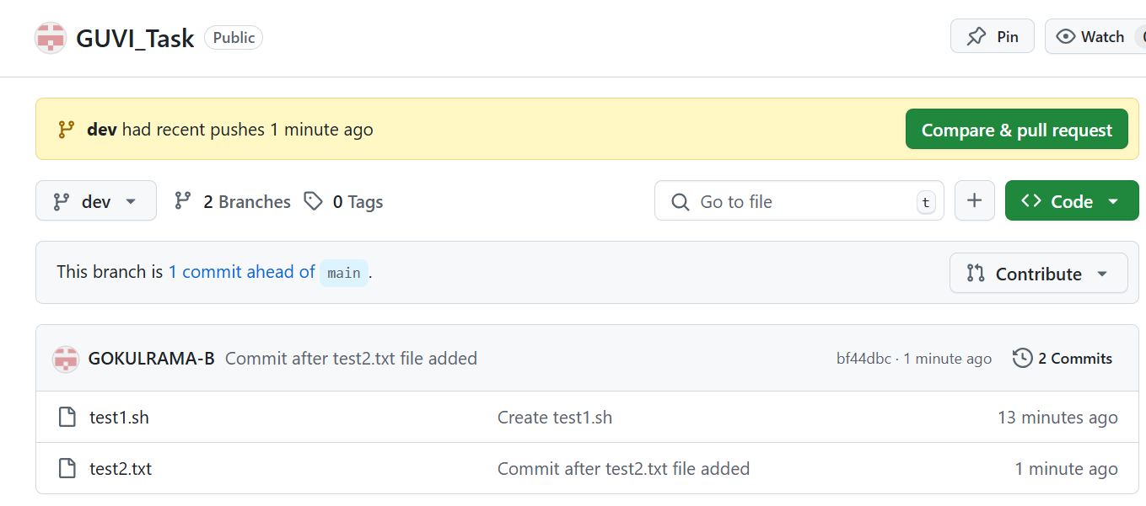

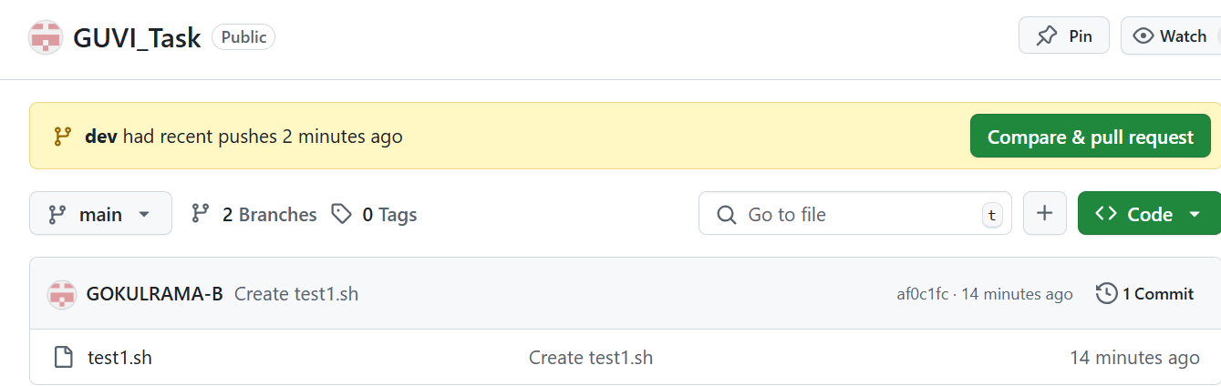

Merging the files from one branch to another branch in GITHUB: -

Here,

Merge the file **from dev branch to main branch**

**Before performing the merge operation,**

**Switch to target branch**

**Enter git command is git merge <source branch>**

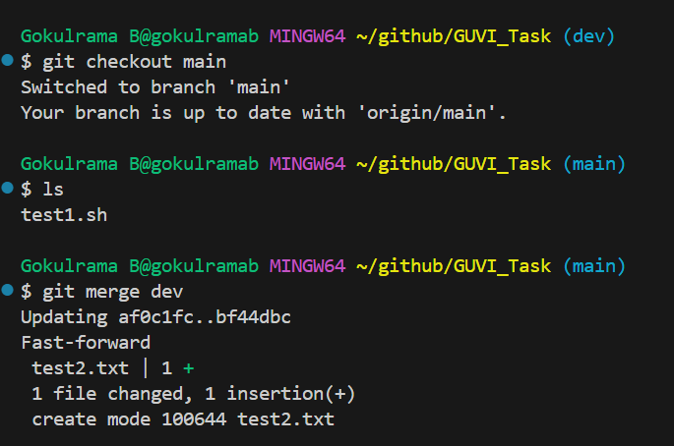

Still the **test2.txt file not available in GITHUB** (**main**) branch, **Reason** is we performed **the merge changes in local git.**

**So, we need to push the changes into remote repo (GITHUB).**

**Switch to source branch – git checkout <source branch>**

**Command is git push origin <target branch>**

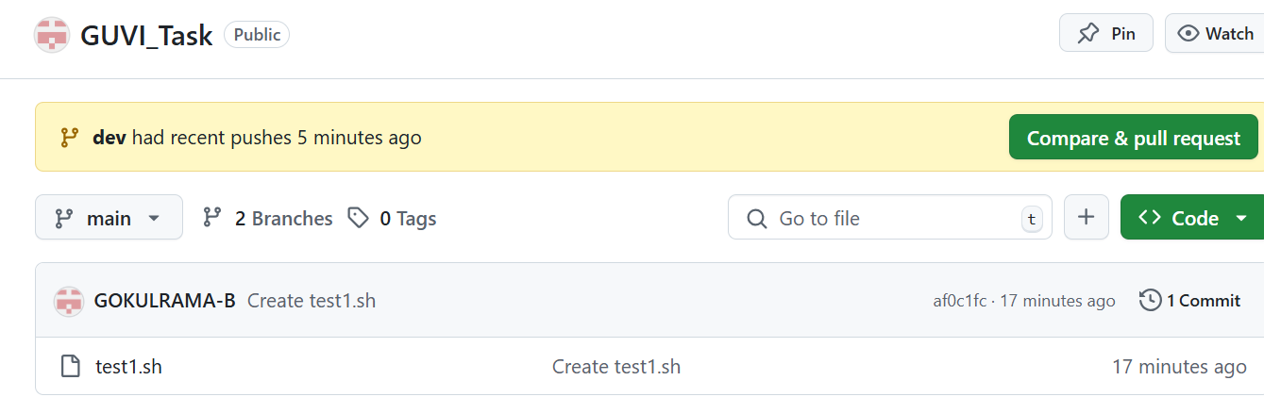

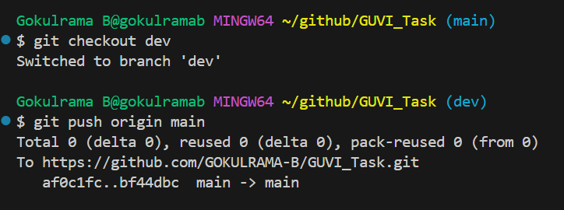

Now the files got **merged from dev branch to main branch**.

